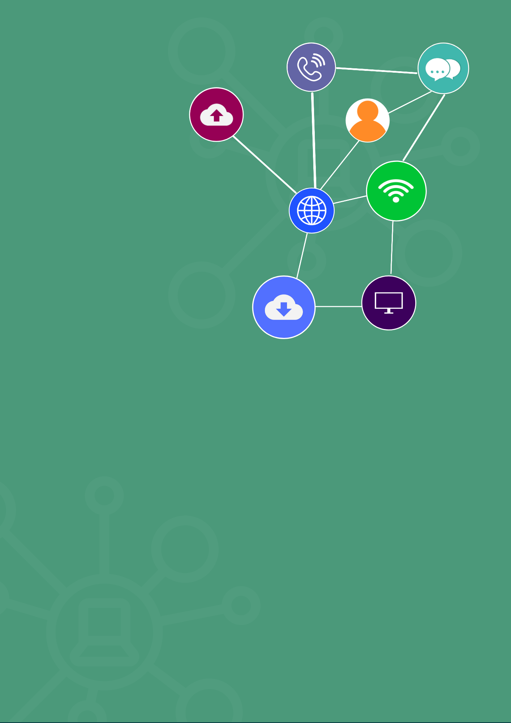
ICTWEB441 Produce basic client-side script
student assessment tasks
Produce basic client-side script

First published 2025
RTO Works
www.rtoworks.com.au
hello@rtoworks.com.au
0452 157 557
© 2025 RTO Works
This resource is copyright. Apart from any fair dealing for the purposes of private study, research, criticism or review as permitted under the Copyright Act 1968, no part may be reproduced by any process without written permission as expressed in the RTO Works License Agreement.
The information contained in this resource is, to the best of the project team’s and publisher’s knowledge true and correct. Every effort has been made to ensure its accuracy, but the project team and publisher do not accept responsibility for any loss, injury or damage arising from such information.
While every effort has been made to achieve strict accuracy in this resource, the publisher would welcome notification of any errors and any suggestions for improvement. Readers are invited to write to us at hello@rtoworks.com.au.
IT Works is a series of training and assessment resources developed for qualifications within the Information and Communications Technology Training Package.




CONTENTS
Introduction 4
Assessment Task 1: Knowledge Questions 5
Assessment Task 1: Checklist 11
Assessment Task 2: Project Portfolio 12
Assessment Task 2: Checklist 15
Final Results Record 17

Introduction
The assessment tasks for ICTWEB441 Produce basic client-side script are outlined in the assessment plan below. These tasks have been designed to help you demonstrate the skills and knowledge that you have learnt during your course.
Please ensure that you read the instructions provided with these tasks carefully. You should also follow the advice provided in the IT Works Student User Guide. The Student User Guide provides important information for you relating to completing assessment successfully.
Assessment for this unit
ICTWEB441 Produce basic client-side script describes the skills and knowledge required to develop interactive and engaging websites, using a range of features from various languages.
For you to be assessed as competent, you must successfully complete two assessment tasks:
- Assessment Task 1: Knowledge questions – You must answer all questions correctly.
- Assessment Task 2: Project – You must work through a range of activities and complete a project portfolio.

Assessment Task 1: Knowledge Questions
Information for students
Knowledge questions are designed to help you demonstrate the knowledge which you have acquired during the learning phase of this unit. Ensure that you:
- review the advice to students regarding answering knowledge questions in the IT Works Student User Guide
- comply with the due date for assessment which your assessor will provide
- adhere with your RTO’s submission guidelines
- answer all questions completely and correctly
- submit work which is original and, where necessary, properly referenced
- submit a completed cover sheet with your work
- avoid sharing your answers with other students.

i | Assessment information  Information about how you should complete this assessment can be found in Appendix A of the IT Works Student User Guide. Refer to the appendix for information on:  - where this task should be completed  - the maximum time allowed for completing this assessment task  - whether or not this task is open-book.  Note: You must complete and submit an assessment cover sheet with your work. A template is provided in Appendix C of the Student User Guide. However, if your RTO has provided you with an assessment cover sheet, please ensure that you use that.

Questions
Provide answers to all of the questions below:
- List and explain three fundamental principles that underpin open programming platforms, using JavaScript as an illustrative example. Number and list your answers, and provide a detailed explanation in at least 120 words.
Answer:
- Open Source Nature: Open programming platforms prioritize free access to source code, enabling community collaboration and modification. JavaScript, as a key web technology, is supported by open standards (e.g., ECMA-262) that allow developers worldwide to contribute to its evolution. For example, frameworks like React and Vue.js leverage this principle to foster collective innovation.
- Cross-Platform Compatibility: These platforms ensure code runs consistently across different devices and browsers. JavaScript achieves this through browser APIs and polyfills. For instance, the Fetch API for network requests works uniformly in modern browsers, minimizing compatibility issues.
- Modularity and Extensibility: Open platforms promote modular code structures, allowing developers to build reusable components. In JavaScript, modules (via import/export) and package managers (e.g., npm) enable seamless integration of third-party libraries, such as Lodash for utility functions.

- Describe the following terms related to client-side (JavaScript) scripting and their application in dynamic web page design. For each term, provide a definition, a coding example, and explain its significance.

Term | Description
Events. List one coding example.  Example:  button.addEventListener('click', () => { alert('Button clicked!'); }); | Events are user actions (e.g., clicks, keystrokes) or browser occurrences (e.g., page load) that trigger script execution.  Significance: Enables interactive user experiences by linking actions to script responses.
Event handlers. List one coding example  Example:  <button onclick="showMessage()">Click me  </button>  <script>function showMessage() { console.log('Message shown'); }  </script> | Functions that process events when they occur, defining the logic for event responses.  Significance: Orchestrates dynamic behavior by mapping events to specific functionalities.
Explain Internet protocols and its significance to client-side script  fetch('api/data') | Rules governing data transmission (e.g., HTTP, HTTPS) that enable client-server communication.  Significance: Client-side scripts use protocols to fetch data, ensuring seamless interaction between the browser and servers.
Hypertext markup language (HTML) and its relationships to client-side script  Example:  JavaScript modifies HTML elements:  document.getElementById('text').textContent = 'Updated!'; | HTML structures web content, while client-side scripts (e.g., JavaScript) enhance its interactivity.  Significance: HTML provides the skeleton, and scripts add dynamic features like form validation.
A standard that applies (defines) HTML and JavaScript | ECMA-262 (JavaScript) and W3C HTML standards define language specifications.  Significance: Ensures consistency across browsers and platforms, enabling reliable development.
- Describe two programming standards relevant to client-side scripting (JavaScript) and provide practical coding examples with comments to illustrate each standard.
Answer:
- ECMAScript (ES) Standards: Define JavaScript syntax and features, e.g., ES6+ introduces arrow functions and template literals.
Example:
// ES6 arrow function for concise syntax
const calculateSum = (a, b) => a + b;
console.log(`Sum: ${calculateSum(5, 3)}`); // Output: Sum: 8
Significance: Promotes code readability and consistency .
- Accessibility (A11Y) Standards: Ensure scripts are usable for people with disabilities, e.g., using aria- attributes.
Example:
<button id="nav-btn" aria-label="Navigate to home page">
Home
</button>
<script>
// Add accessible event handling
document.getElementById('nav-btn').addEventListener('click', () => {
navigateToHome();
});
</script>

Significance: Enhances inclusivity and compliance with web accessibility guidelines.

- List two methods for testing scripts within a website, and provide a pros and cons analysis for each method.
Answer:
- Browser Developer Tools (e.g., Chrome DevTools)
  - Pros: Built-in debugging tools (breakpoints, console logs), real-time code modification, and network monitoring. Ideal for quick testing .
  - Cons: Limited to single-browser testing; requires manual execution for each scenario.
- Unit Testing Frameworks (e.g., Jest, Mocha)
  - Pros: Automates testing of small code units, supports cross-browser testing via tools like Selenium, and generates detailed reports .
  - Cons: Requires setup time, may not fully replicate real-user interactions, and focuses on isolated components.

- Explain the purpose of server-side and client-side scripting. List at least three differences between them and provide coding examples to illustrate these differences.
Answer:

Purpose Analysis
- Client-side Scripting (e.g., JavaScript):
Runs in the user's browser to manipulate web page DOM elements and implement interactive logic. Its core goal is to optimize user experience (e.g., real-time form validation, dynamic page rendering).
- Server-side Scripting (e.g., Node.js/Python):
Executes on the server to handle data processing, business logic, and resource management (e.g., database operations, user authentication). Its core goal is to ensure data security and stable execution of server-side logic.
Differences:
  - Execution Environment:
    - Client-side: Browser (e.g., JavaScript).
    - Server-side: Server (e.g., Node.js).
Example:
// Client-side: Validate form input
document.getElementById('form').addEventListener('submit', (e) => {
e.preventDefault();
if (!document.getElementById('email').value) alert('Enter email');
});

  - Data Security:
    - Client-side: Code is visible to users (potential security risks).
    - Server-side: Code runs on secure servers, protecting sensitive logic.
Example:
python
运行
# Server-side: Secure database query (Node.js with Express)
app.post('/login', (req, res) => {
const user = db.query('SELECT * FROM users WHERE email = ?', [req.body.email]);
// Hash password before comparison
if (bcrypt.compare(req.body.password, user.password)) res.send('Authenticated');
});

  - Resource Impact:
    - Client-side: Depends on user’s device performance.
    - Server-side: Consumes server resources (CPU, memory).
Significance: Client-side scripts optimize load times, while server-side scripts handle heavy processing .

Assessment Task 1: Checklist
Student’s name:
Did the student provide a sufficient and clear answer that addresses the suggested answer for the following? | Completed successfully? |  | Comments
 | Yes | No
Question 1
Question 2
Question 3
Question 4
Question 5
Task outcome: | - Satisfactory |  |  | - Not satisfactory
Assessor signature:
Assessor name:
Date:

Assessment Task 2: Project Portfolio
Information for students
In this task, you are required to demonstrate your skills and knowledge by working through a number of activities and completing and submitting a project portfolio.
You will need access to:
- a suitable place to complete activities that replicates an ICT environment including a meeting space, a digital device and software and internet access
- ICTWEB441 Simulation Pack or access to client requirements that include functionality and scope requirements for the website and procedures for developing website including cyber security procedures/protocols
- your learning resources and other information for reference
- Project Portfolio template.
Ensure that you:
- review the advice to students regarding responding to written tasks in the IT Works Student User Guide
- comply with the due date for assessment which your assessor will provide
- adhere with your RTO’s submission guidelines
- answer all questions completely and correctly
- submit work which is original and, where necessary, properly referenced
- submit a completed cover sheet with your work
- avoid sharing your answers with other students.

i | Assessment information
Information about how you should complete this assessment can be found in Appendix A of the IT Works Student User Guide. Refer to the appendix for information on:
- where this task should be completed
- how your assessment should be submitted.
Note: You must complete and submit an assessment cover sheet with your work. A template is provided in Appendix B of the Student User Guide. However, if your RTO has provided you with an assessment cover sheet, please ensure that you use that.

Activities
Complete the following activities:
- Carefully read the following:
 | This project requires you to develop an interactive and engaging website according to client requirements. To do this, you will need to produce a client-side script using a language to meet the required functionality.  This project is to be based on client requirements as per the ICTWEB441 Simulation Pack and a meeting with the client (your assessor). Speak to your assessor to get approval if you want to base this on another business or client requirements for a website. If you want to base this on another business, you will need to be able to access documentation and information about client requirements, as well as procedures and protocols that need to be followed to ensure cyber security.
 | Vocational education and training is all about gaining and developing practical skills that are industry relevant and that can help you to succeed in your chosen career. For this reason, basing your project on real requirements will mean that you are applying your knowledge and skills in a relevant, practical and meaningful way!
 | You will be collecting evidence for this unit in a Project Portfolio. The steps you need to take are outlined below.
- Preparation
 | Read through the Simulation Pack that includes initial details of the client requirements and procedures that you must follow for producing client-side script for a website. If you are completing this for your own business, review documentation you can access the relates to client requirements concerning the project.  Complete Page 4 of your Project Portfolio for this unit.  Read through the requirements of Section 1 and 2 of your Project Portfolio which include detailed guidance relevant to all the assessment activities.
- Preparation and client meeting
   | The first part of this assessment requires you to prepare to develop your website and to meet with the client to discuss their requirements.  Before the meeting you are to review the client’s initial documentation so that you understand overall requirements. Further, make sure you understand the requirements you need to follow for website development. Work on Section 1 of your Portfolio.  Based on your review of the client’s initial documentation, identify additional information you need to find out so that you are prepared for the meeting.  During your meeting with the client your assessor will be looking to see that you can:  - Confirm your understanding of the client’s requirements using listening and questioning techniques  - Articulate information clearly and in language that the client can understand.
i | Make notes on the information you receive at the meeting answers and record the information in your Portfolio (Section 1) to refer to in the upcoming activities.  Your assessor can provide you with more details at this step. Make sure you follow the instructions above and meet any timeframes allocated.
- Design, produce and test website
 | You are now to design, produce and test your website. Complete section 2 of your Project Portfolio including:  - Designing the website based on the client’s requirements  - Developing a simple HTML language for the website (ensuring accessibility)  - Writing and producing embedded scripts for the website  - Testing the website including scripts developed to ensure it is secure and bug free.  Complete Section 2 of your Portfolio.
- Submit your completed Project Portfolio
 | Make sure you have completed all sections of your Project Portfolio, answered all questions, provided enough detail as indicated and proofread for spelling and grammar as necessary.  Submit to your assessor for marking.

Assessment Task 2: Checklist
Student’s name:
Did the student: |  | Completed successfully? |  |  | Comments
 |  | Yes | No
Determine and report on the dynamic functionality for the web site?
Identify and report on the required language according to required functionality?
Engage in client discussions to determine web document requirements?
During the meeting with the client, use questioning and listening techniques to gain the information required?
During the meeting with the client, articulate information clearly and in language that the client can understand?
Confirm level of documentation required for the website?
Design web document and embedded scripts to meet requirements?
Write a simple hypertext markup language (HTML) for the website ensuring accessibility?
Write and produce embedded scripts as per website requirements?
Test web document and scripts against the required functionality and reiterate accordingly?
Confirm required functionality is achieved by undertaking the testing process?
Test website to ensure it is secure and bug free?
Complete documentation and submit for approval?
Task outcome: | - Satisfactory |  |  | - Not satisfactory
Assessor signature:
Assessor name:
Date:

Final Results Record
Student name:
Assessor name:
Date
Final assessment results
Task | Type | Result
 |  | Satisfactory | Unsatisfactory | Did not submit
Assessment Task 1 | Knowledge questions | S | U | DNS
Assessment Task 2 | Project Portfolio | S | U | DNS
Overall unit results |  | C | NYC
Feedback

- My performance in this unit has been discussed and explained to me.
- I would like to appeal this assessment decision.

Student signature: Date:

- I hereby certify that this student has been assessed by me and that the assessment has been carried out according to the required assessment procedures.

Assessor signature: Date:

